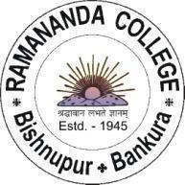
RAMANANDA COLLEGE
e-mail –principal@ramanandacollege.org
Website-www.ramanandacollege.org
Mobile- 6297976619

BISHNUPUR * BANKURA
Pin – 722122, West Bengal
UGC Recognized & State Government Aided Constituent College
Under the Bankura University
(Accredited by NAAC at B++ Level in 2021)
_________________________________________________________________________________________

TCS B.Sc. Ignite Hiring 2026 — Campus Recruitment Drive

Official Registration Link
https://www.tcs.com/careers/india/tcs-bsc-ignite-Hiring?utm_source=Social+Media&utm_medium=Mailer&utm_campaign=TCS-Bsc-Ignite-Hiring-2026

